**Predictive Analysis and Visualization of Healthcare Market Trends**

**🧪 Testing and Evaluation**

This documents the full testing and evaluation phase of the system, from functionality to model accuracy, and includes descriptions for screenshots to be added in the Word file. The goal is to ensure that the system is stable, accurate, and ready for end-user interaction.

**Types of Testing are given Below:**

1. Model Evaluation
2. Local Host Generate Testing
3. Functional Testing
4. Demo Testing
5. Subscription Testing
6. User Dashboard
7. MongoDB Testing
8. PowerBI/Tableau Integration Testing
9. Error Handling Testing
10. Mobile/Desktop browser compatibility
11. **Model Evaluation:**

* Machine Learning Models
* **Linear Regression Model testing:**

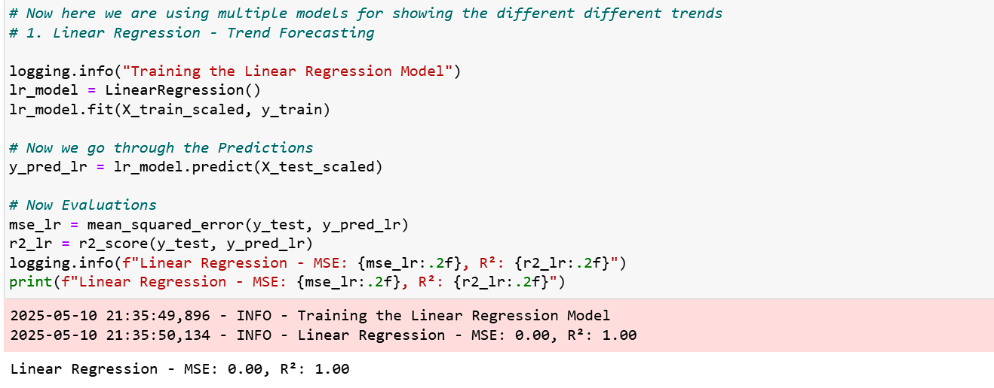

In this Linear Regression the Model is trained and Accuracy us near by 1 means 98% accuracy is occurred.

* **Random Forest Regressor testing:**

In this Random Forest model is trained and accuracy is near by means 25% accuracy occurred. Actually this is for the Complete Pattern Detection and Accuracy is not the best fit for the Pattern Detection.

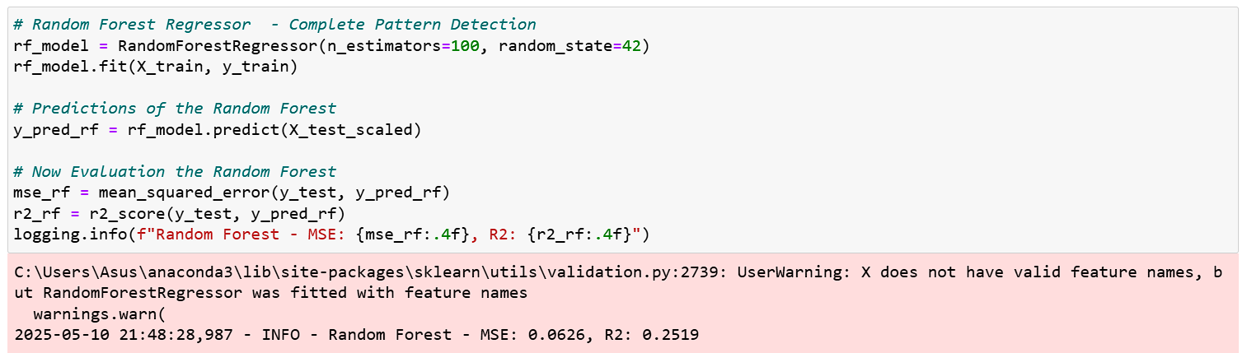

* **XGBOOST testing:**

In this XGBOOST model is trained very well and accuracy is near by 1 means 97 to 98% accuracy is occurred. Actually this is for the market Trend Analysis.

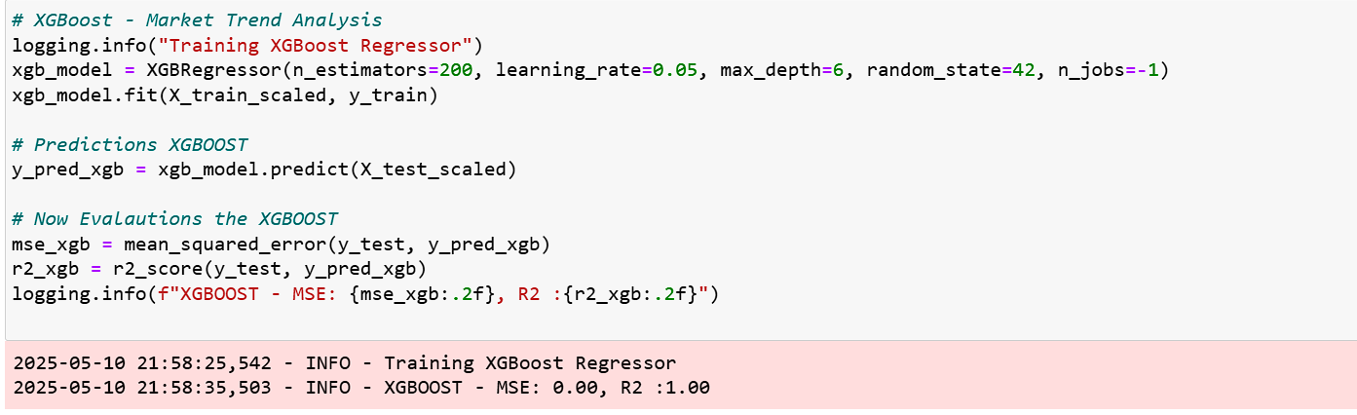

* **ARIMA: for 10-year disease forecasting testing:**

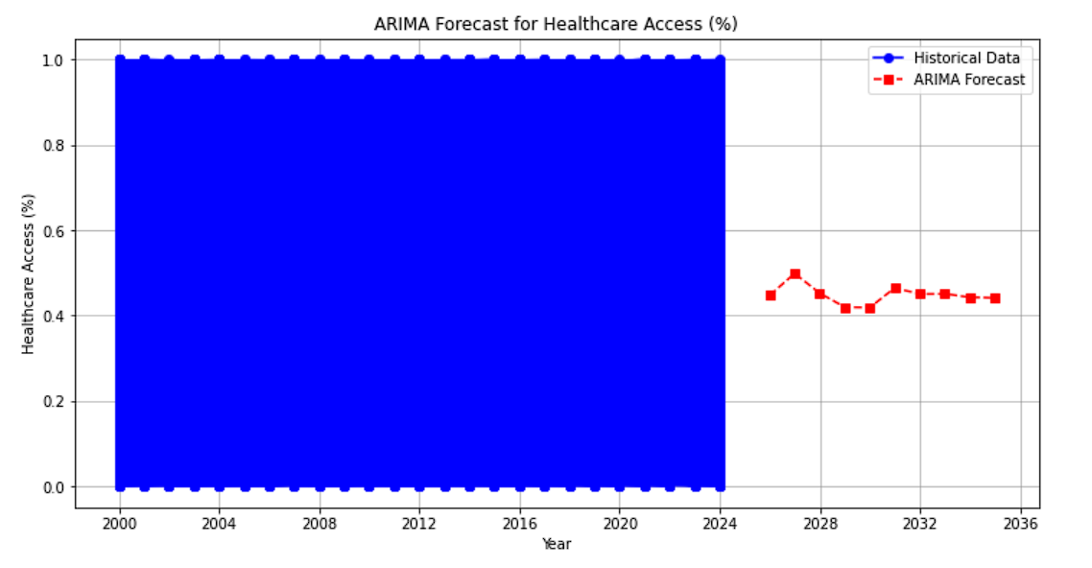

Now time for healthcare access for the next 10 years:

Now time for the Disease prediction for next 10 years:

This is the Disease forecasting Image and this image shown the how can multiple disease is trending next 10 years.

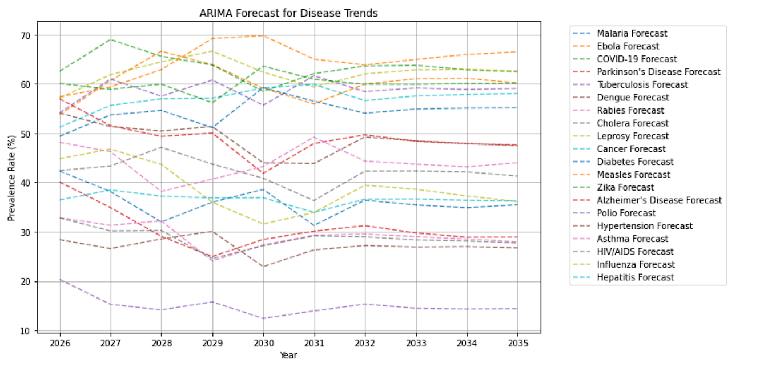

In this time series forecasting there is forecast about healthcare and disease forecast next 10 years. There are multiple disease is trended previous years. So now help of the time series forecasting we know that how the Disease is trending in Upcoming in the future time.

1. **Local Host Generated Testing:**

* Now we can checking the local host is really generated is not. If the code is well runnable then Automatically run the terminal then use this command npm run dev then, generate the local host link:
* The Screen short is given below: -

1. **Functional Testing:**

* **User Signup**

In this signup form fill all the necessary fields with accurate answer:

* The Screenshot is given below: -

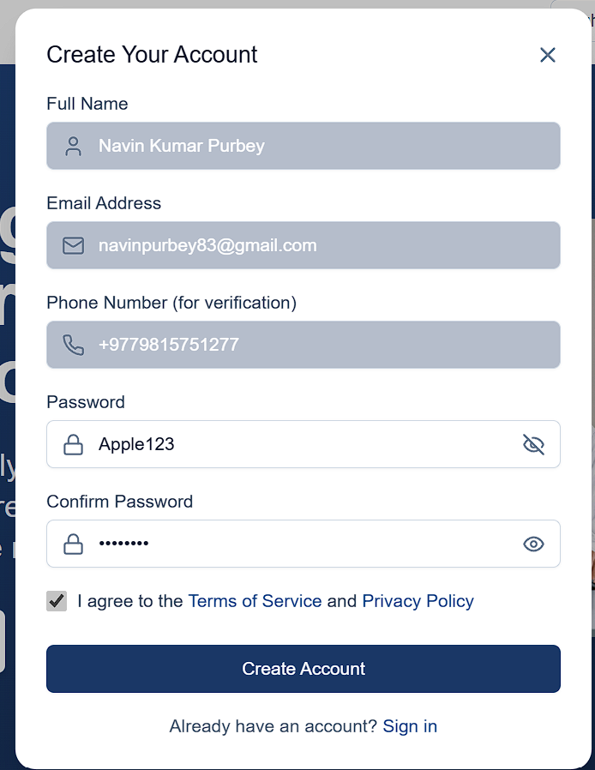

* **Error checking while filling the form:**
* The Screenshot are given below: -

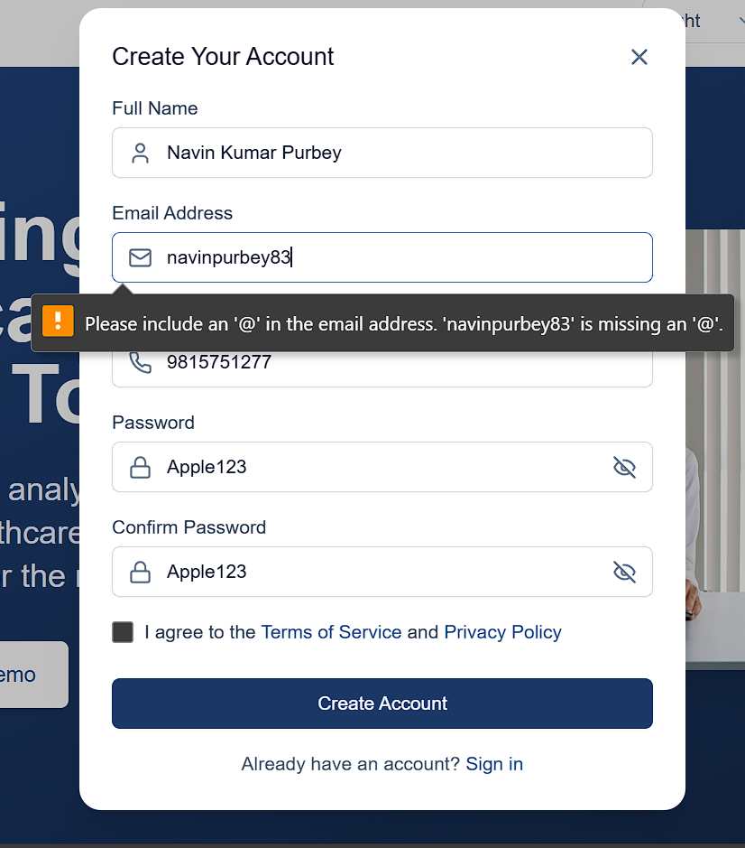

In this screenshot you can see the warning button is please include proper mail. This is the good UI - user Interface for this website.

* **Checking the Verification options:**

In this options is verify through otp now we can see the actually it is possible or not:

The screenshot are given below:

Now we see the yeah it is working with proper way and there is also options is available called Resend Code where if code is not working then we use the resend code button.

* **Checking the User Login button:**

In this signin button there is the possible to we have already have account. If we have already account then simple way is Just Fill the Email with proper password.

The Screenshot are given below:

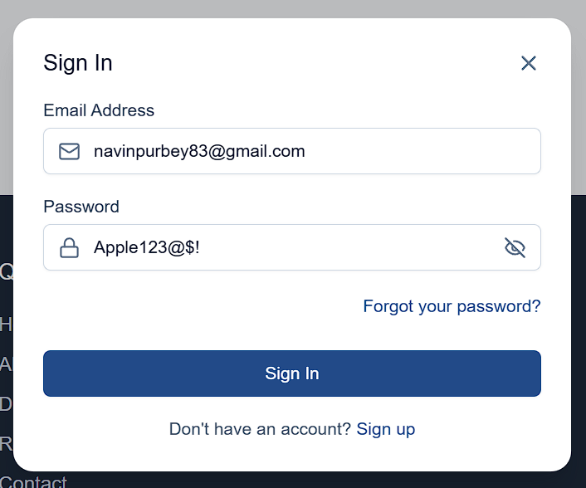

Yeah it is working in proper way.

* Now checking the UI proper way working is not.
* The screenshot are given below:

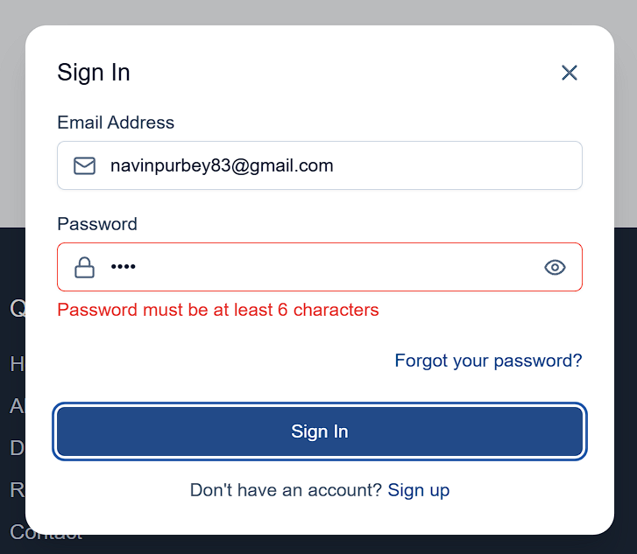

Yeah it’s all working very well…

1. **Demo Testing:**

* In this part of testing is know for demo test because there is no login , no signin, no signup not do anythings just go the home button then try Demo account. We can see the Disease Graph and Healthcare graph but not access the PowerBI/tableau Dashboard.

The screenshot are given below:

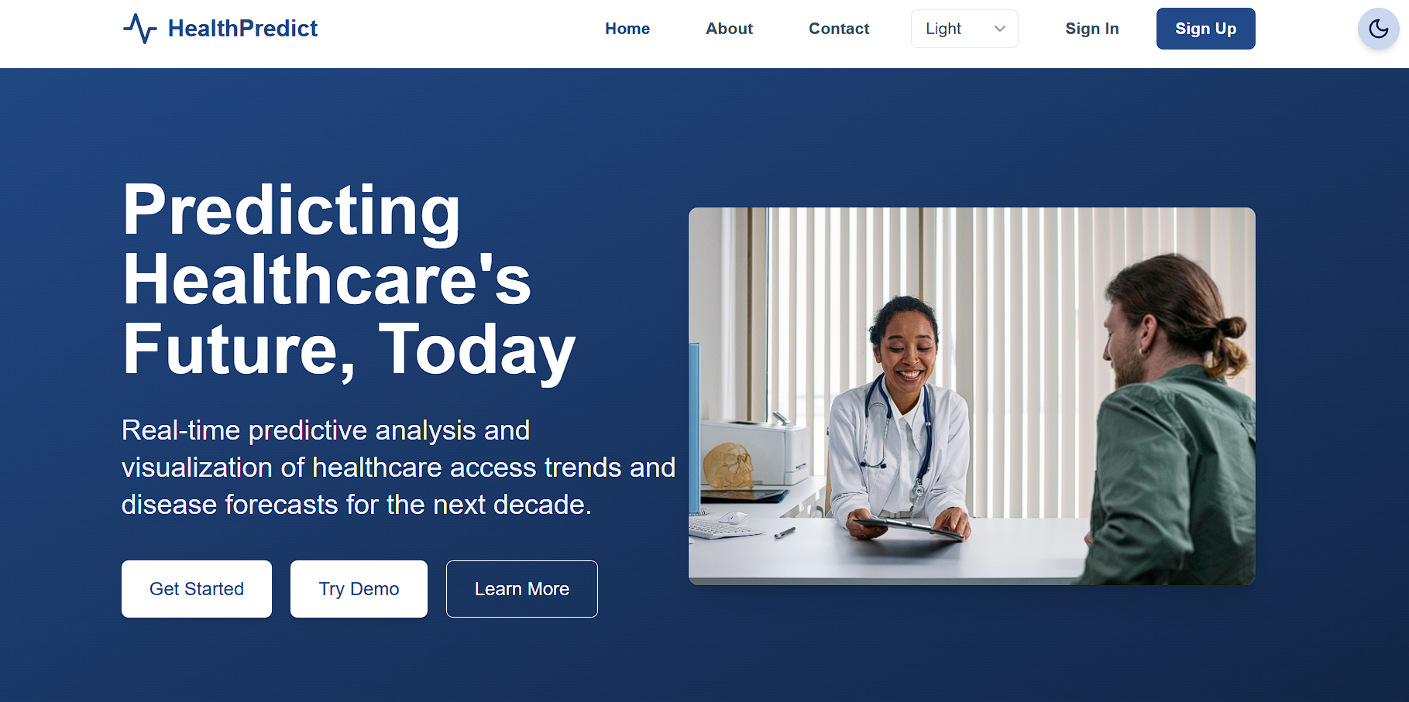

We can see the Try Demo means this is just for the demo account. Now see the next screenshot are given below:

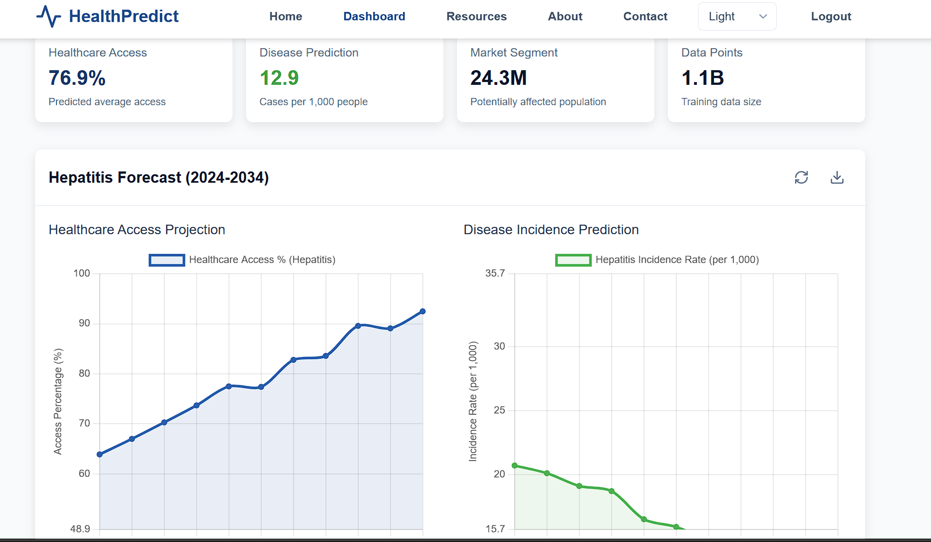

In this screenshot you can see the Healthcare predictions and Disease predictions with graph but not access though Demo account. If you try to get access the PowerBI/Tableau then they say for the Update to access means first pay then only you suitable to see the whole Dashboard PowerBI/Tableau and Disease Predictions and Healthcare access.

The screenshot are given below:

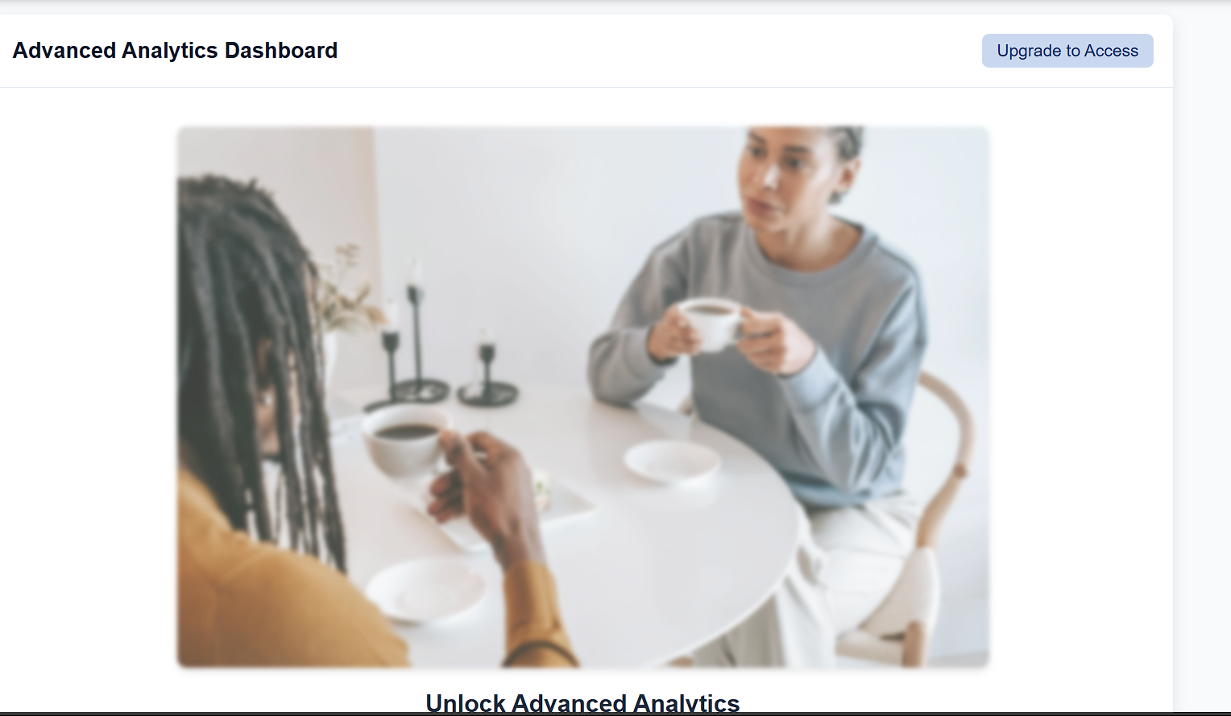

Yeah actually it is real word about Upgrade pass. First Pay then unlock the Advance Analytics dashboard.

1. **Subscription Testing: -**

* In this Section we go to check the Subscriptions Workflow. Actually how the subscription works flow is going to. If we try to access the Advance analytics dashboard while loging to Try Demo account then first pay. Now we check how we pay the System.

The screenshot are given below: -

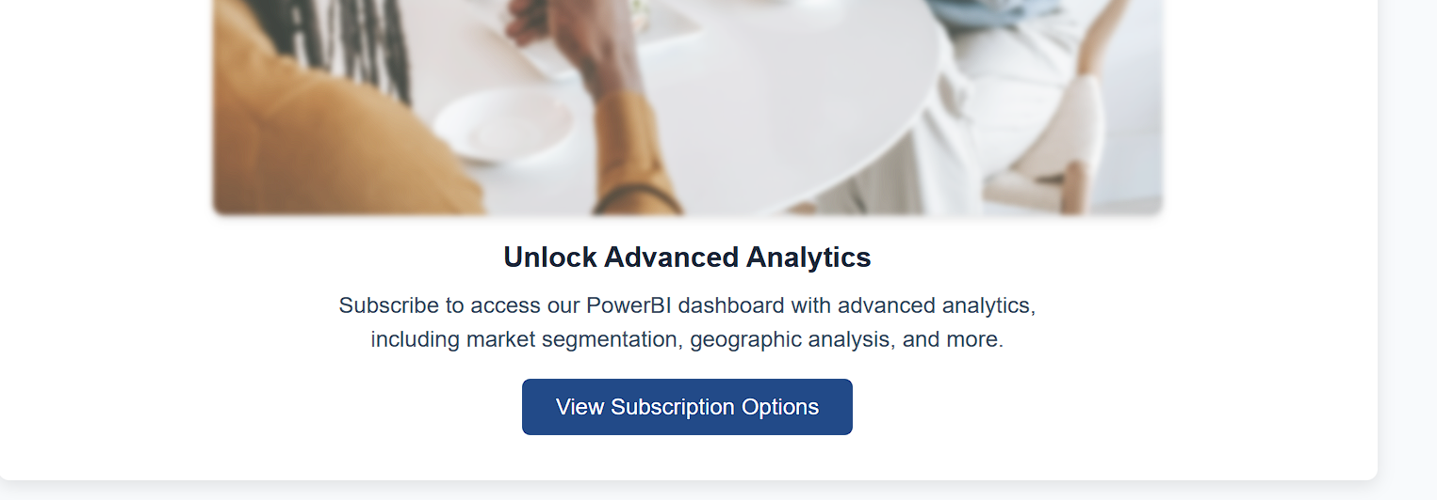

Now you can see the Unlock Advance Analytics Subscription options. If we click the View Subscription Options then they show the some plans to buy.

The screenshot are given below: -

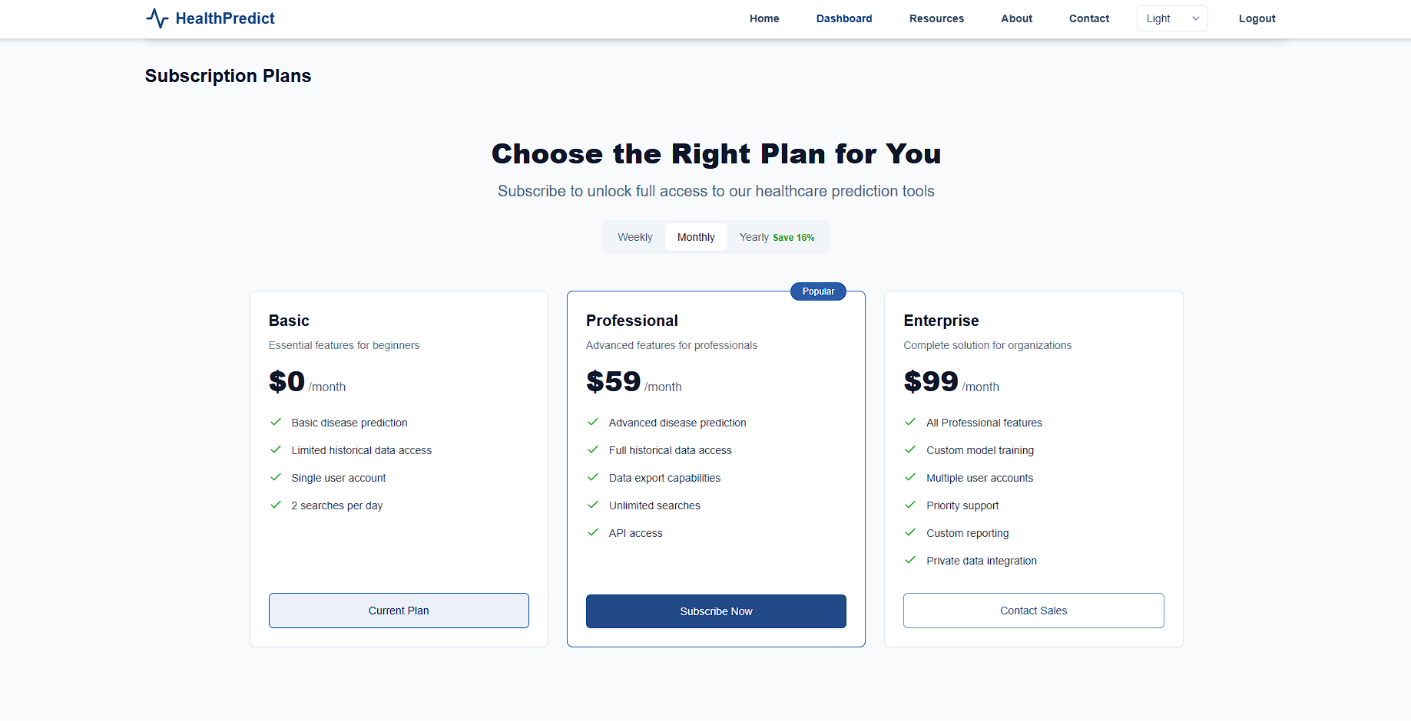

Yeah it is working properly. There are multiple way to buy like Weekly, Monthly or Yearly.

1. **User Dashboard Testing:**

* In this section we can see the dashboard of multiple things like Multiple Diseases with Healthcare access in the form of Graph dashboards visualization.

The Screenshot are given below:-

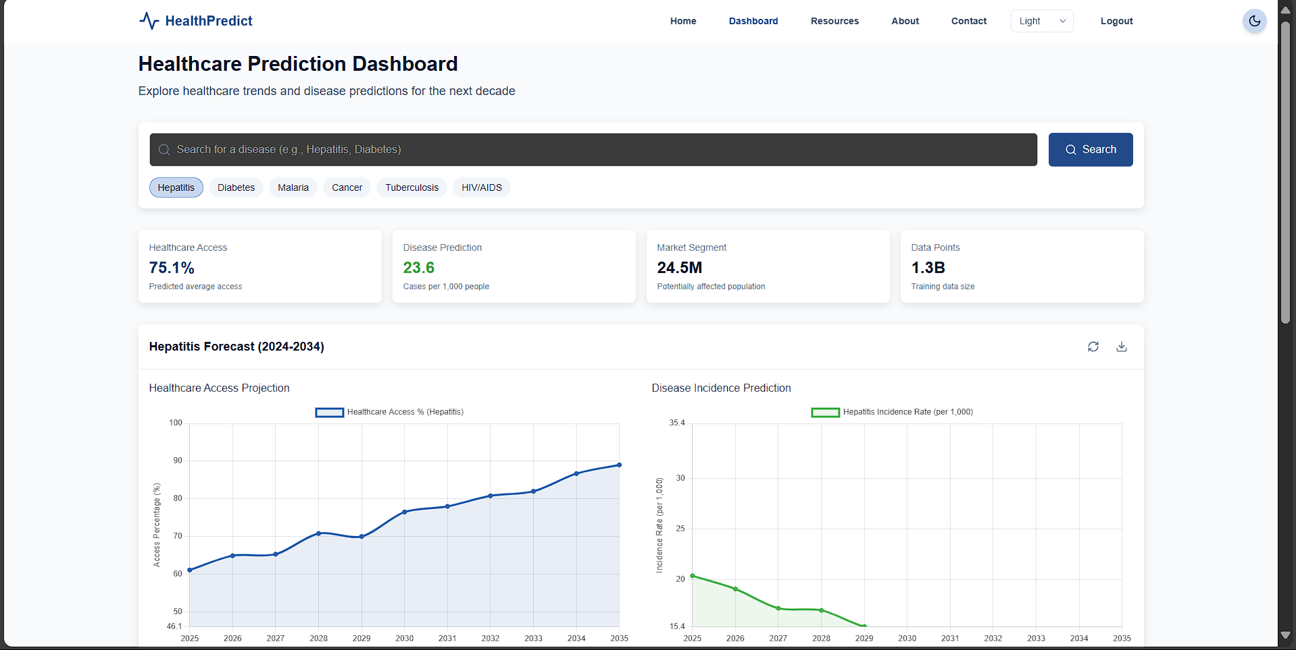

We see that the Dashboard is working with showing the Graph of Healthcare Access and Disease Incident Predictions.

Now Click the some disease then what is the next workflow of graph.

The Screenshot are given Below: -

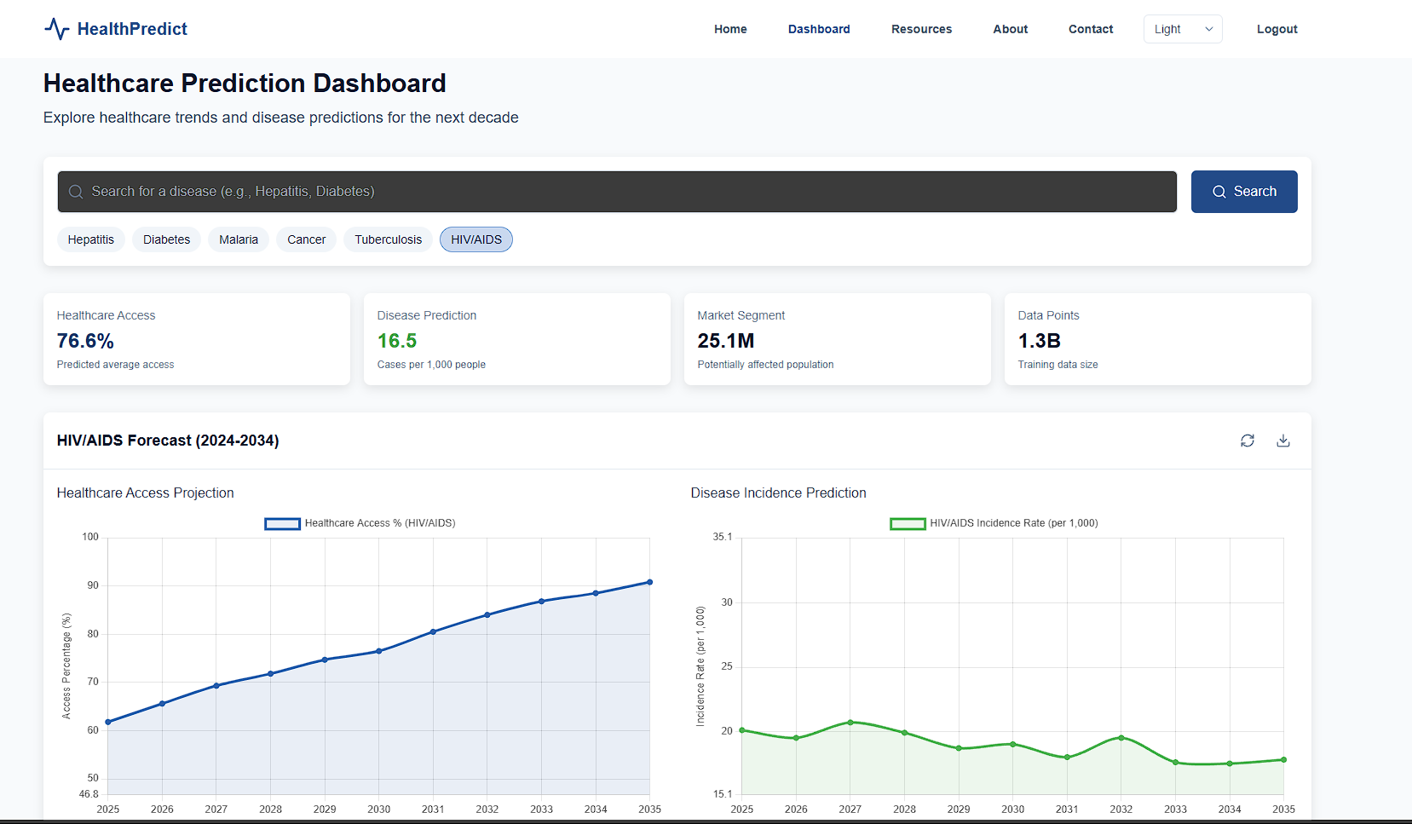

Here we can see the changing of graph while clicking the Disease. Now I clicked the HIV/AIDS the they show some points about healthcare access and some another things are show.

1. **MongoDB Testing: -**

* In this section we can test the actually data is workflow or not. Each time User is login then In database record activities about user and collect the user Information’s.

The Screenshot are given below:

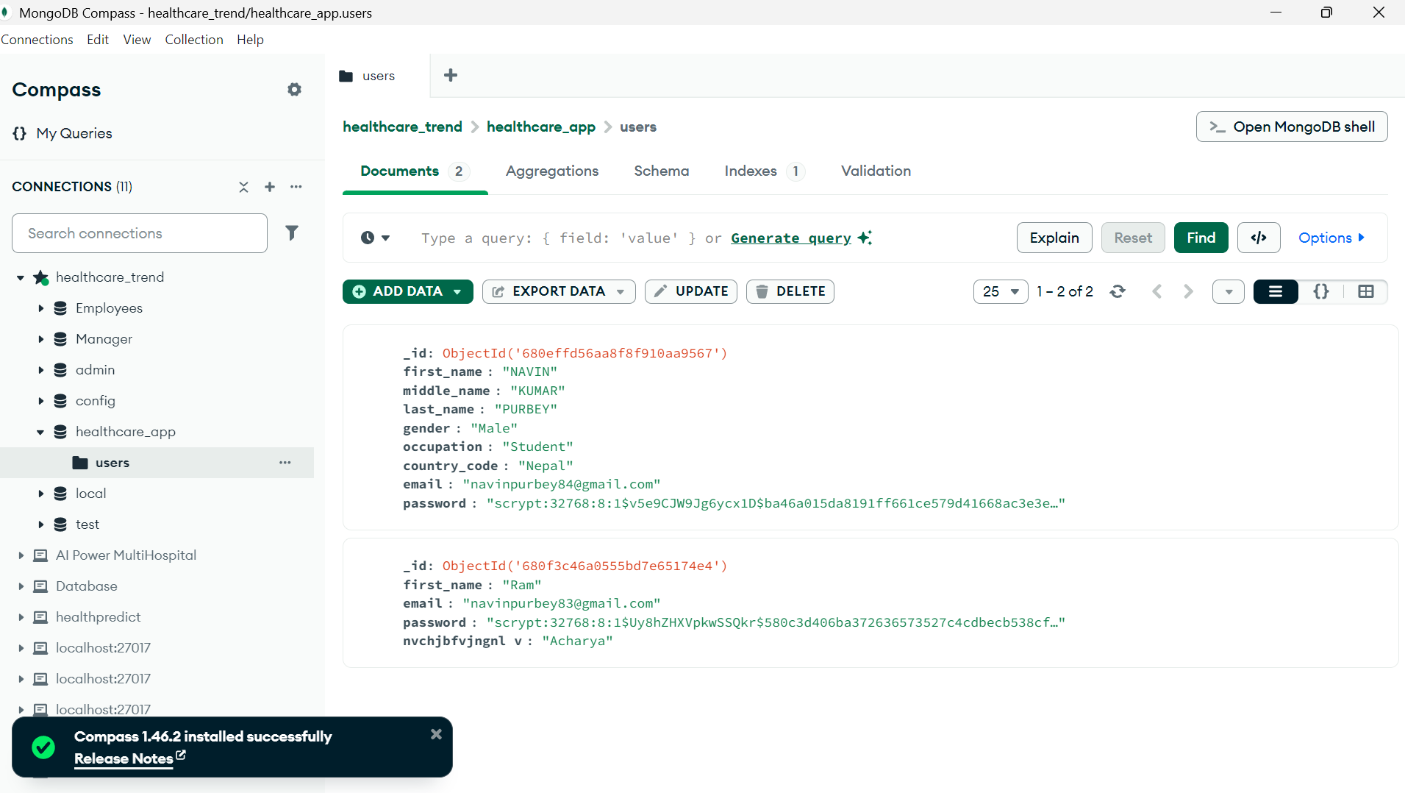

Here we can see the user details is recorded.

1. **PowerBI/Tableau Integration Testing: -**

* In this Visualization testing, we using the PowerBI or Tableau for the Creating Dashboard and implementation in the WebApp in the dashboard Sections.

The Screenshot are given below:

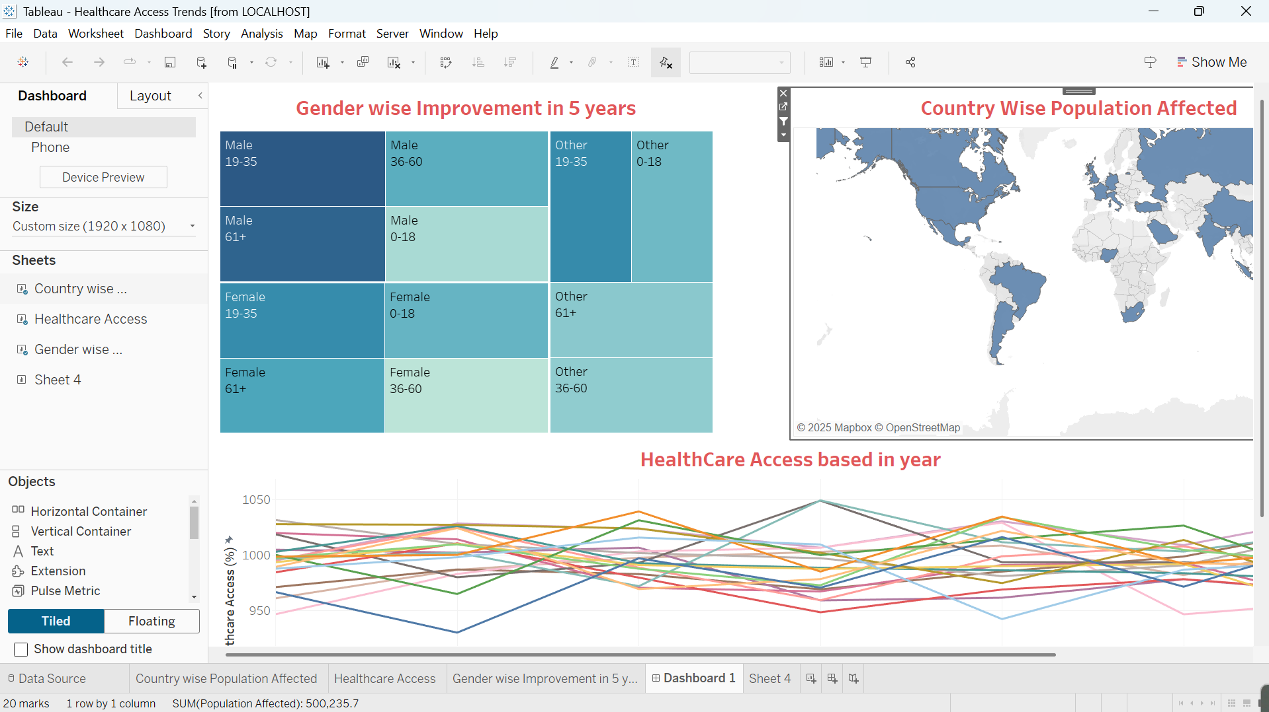

1. **Error Handling Testing: -**

* In this sections We go for the error handling checking where we can see the user interface is working properly is not.
* **Invalid Email Format**

The Screenshot are given below:

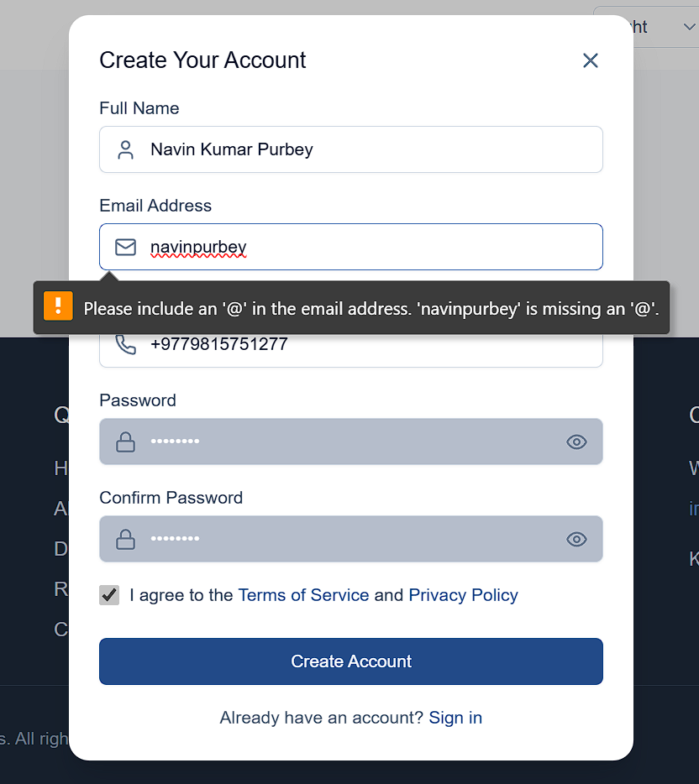

Yeah it is working very well.

* **Password too Short:**

The screenshot are given below:

Here we see the working of Password too short workflow.

1. **Mobile/Display browser compatibility Testing:**

* In this section we can see the how actually User Interface is working is well or not. If I click Mobile compatibility then actually see the mobile version type

The Screenshot are given below:

Yeah it is really working with Mobile Compatibility Version.

In summary all the testing and Evaluation is passed with the proof of screenshot. All the major modules passed test scenarios. The system remains stable with multiple users.